Declaration of Originality:
We hereby declare that the report entitled “UniCare Clinic Booking System” submitted for the

module ITS 610204/ITS 64604: PRINCIPLES OF SOFTWARE , Semester: February 2026 is entirely our own original work; no part of this report has been copied from other students, published works, or any other source without proper acknowledgment, and no unauthorized assistance (including any AI text generation tool) has been used in preparing this report, and we understand that any violation of this declaration may result in academic penalties.

Student Name | Student ID | Signature
Group Leader Name:
Member:  Zou Chong | 0373901 | 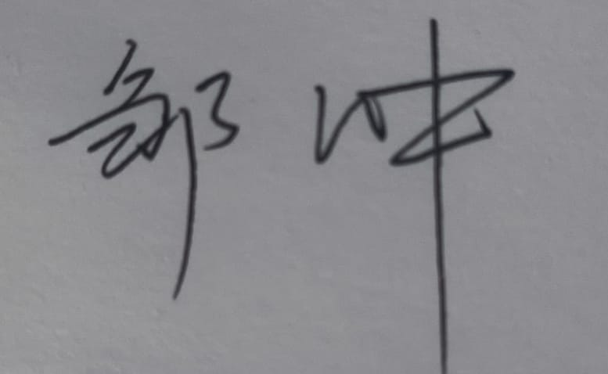
Member:  Itsuki Agematsu | 0391844 | 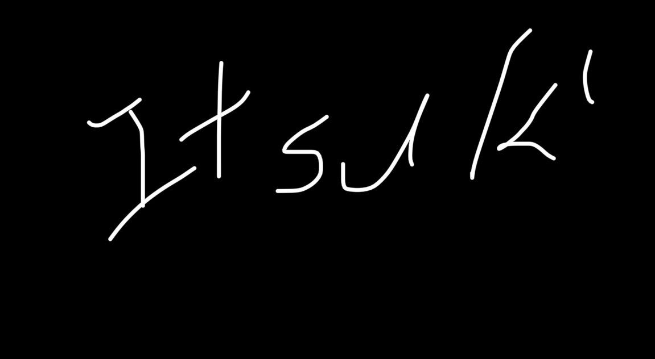
Member:
Member:

UniCare Clinic Booking System

1.Project Introduction
UniCare is a software prototype that [rehabilitates|optimizes] the user experience to bring about better access to campus healthcare through booking and managing students’ clinic appointments.
Too many university clinics still operate on a manual or cumbersome scheduling system that often causes delays, double bookings, and challenges in tracking appointments. With UniCare, students and parents can register and log in to a digital platform, check availability, book appointments, and even manage their bookings.
Daily schedules, clinic appointments, and appointment status may be checked by clinic personnel. With the appointment system now digital, UniCare streamlines processes and facilitates students getting medical aid in a timely manner.
This project promotes good health and well-being (SDG 3) through improving access to healthcare services on campus for students.

2.Problem Statement
College students typically experience barriers in accessing on-campus health services. Traditional methods of appointment scheduling include the manual booking and that provides no information on which time slots are available, and students calling back to the clinic to enquire availability.
As a result, these problems can lead to missed appointments, delayed services, and a poorly managed appointment system. In the absence of a well-established electronic system, the clinic personnel also might face challenges in scheduling and tracking patient visits.
Hence a straightforward and effective appointment scheduling system is essential to enhance accessibility and the provision of campus health services.

3.Target Users
Primary users:
- University students who need to make clinic appointments.
- Campus clinic personnel booking appointments

Secondary Users:
- Doctors and healthcare providers in the campus clinic
- University health administrators

4.Vision Statement
To design a streamlined digital service platform, through which university students can conveniently book and manage appointments at campus clinics, while campus clinics are aided with schedule organization and in making healthcare more accessible.

5.Key System Features
Student Functions:
- Register and login
- View available appointments slots
- Schedule clinic appointments
- Select symptom category
- View appointment history
- Cancel appointments

Clinic Staff Functions:
- View daily appointment schedule
- Manage appointments
- Confirm or reject bookings
- Update appointment status (checked-in, completed, cancelled, no-show)

6. Example Product Backlog (Agile)
User stories for students:

ID | User story | Priority
US1 | I want to register an account to use the system. | High
US2 | I want to login to my account. | High
US3 | I want to view available clinic appointment slots | High
US4 | I want to book an appointment by selecting date and time | High
US5 | I want to choose a symptom category when booking. | Medium
US6 | I want to view my appointment history. | Medium
US7 | I want to cancel an appointment. | Medium

User stories for clinic staffs:

ID | User story | Priority
US1 | I want to view the daily appointment schedule | High
US2 | I want to confirm or reject appointments | High
US3 | I want to update appointment status | High

7.Sprint Plan
Sprint 1 (Week 1–2)
Focus : Planning and System Design

Tasks:
- Define project scope
- Develop product backlog
- Write user stories
- Draw use case diagram
- Create class diagram
- Design UI wireframes

Sprint 2 (Week 3–4)
Focus: Prototype Development and Testing

Tasks:
- Develop system prototype
- Test booking workflow
- Gather feedback
- Refine prototype
- Complete report and presentation

8 .Trello Board Structure
Create a board called:
UniCare Agile Project

Lists:

Product Backlog
To Do
Doing
Done

Sample tasks:
- Write the introduction for the project
- Specify the user stories
- Draw UML diagrams
- Design wireframes
- Build a prototype
- Perform testing
- Prepare the final report

9. Agile Methodology
This project uses the Agile software development method to allow for flexible and iterative development. Agile emphasizes collaboration, continual improvement, and responsiveness to change during the development lifecycle.
The team adopted a sprint framework to structure work around project tasks. The development was split into two sprints. Members of the team focused on tasks from the product backlog during each sprint. With this method, the team was able to progressively develop the system prototype.
Trello, which supports Agile task management, was used by the team as a Kanban board to visually manage tasks and track progress. Tasks were broken down into lists like Product Backlog, To Do, Doing, Done. This made it easier for the team to track the progress of work and handle obligations.
Also, the team utilized GitHub for file and project management and for tracking development work. On GitHub, version control was established and team members were enabled to upload documents, prototypes, system design artifacts while the history of the progress of the project was preserved.
Using agile methodologies, tools for collaboration, the team was able to effectively coordinate the work and have a consistent progress throughout the development.

10. System Requirements
Functional Requirements

Description of Functional Requirements – defines the system functions which the system must provide to its end users The To requirements: Report generation UniCare must produce reports for the following functions.
Enable students to register and log in to use the platform. Students should be able to log in, see the open slots at the campus clinic, make an appointment by choosing a date, time, and category of symptoms.
Students should also have the opportunity to access their existing bookings and cancel them. This makes it easier for students to schedule clinic visits.
For clinic staff, the system must allow them to view a day-by-day appointment list. The staff should also have the facility to add or remove appointments, as well as to change the appointment status i.e checked-in, completed, cancelled or no-show. These processes ensure the clinic is able to keep a tidy schedule and increase its working rhythm.

ID | Requirement | Description | User Type
FR1 | User Registration | Students can create an account with email and password | Students
FR2 | User Login | Students can log in to the system securely | Students
FR3 | View Available Appointments | Students can view available time slots and symptom categories | Students
FR4 | Book Appointment | Students can book an appointment by selecting date, time, and symptom category | Student
FR5 | View/Cancel Bookings | Students can view their booked appointments and cancel if needed | Student
FR6 | Notifications | Students receive reminders for upcoming appointments | Student
FR7 | Manage Daily Schedule | Clinic staff can view all appointments for the day | Staff
FR8 | Update Appointment Status | Staff can mark appointments as checked-in, completed, cancelled, or no-show | Staff
FR9 | Confirm/Reject Appointments | Clinic staff can confirm or reject new appointments | Staff

Non-Functional Requirements
Non‐functional requirements specify the quality attributes, system performance and constraints.
First, the system need to be simple and consider user-friendly so that students can find out quickly how to make an appointment. The usability practice is essential to confirm that users can easily use the system.
Second, user information, such as login passwords and appointment information, needs to be secured by the system. Need to implement some basic authentication mechanism and prevent unauthorized access.
Third, the system should maintain a reliable performance to ensure that no system error occurs while booking or updating an appointment. The system should be fast in responding to user's command, when a user is viewing a schedule, or making an appointment.
Finally, the system should be compatible with common devices (e.g., laptops, phone) for the convenience of students.

ID | Requirement | Description
NFR1 | Usability | The system should be easy to use with a clear interface for students and staff
NFR2 | Security | User data, such as login credentials and appointment details, must be protected
NFR3 | Performance | The system should process bookings, updates, and cancellations quickly without errors
NFR4 | Reliability | System should be available and functional with minimal downtime
NFR5 | Accessibility | System should be accessible on laptops, tablets, and smartphones
NFR6 | Maintainability | The system design should allow easy updates and modifications in the future

11. System Design
11.1 Class Diagram
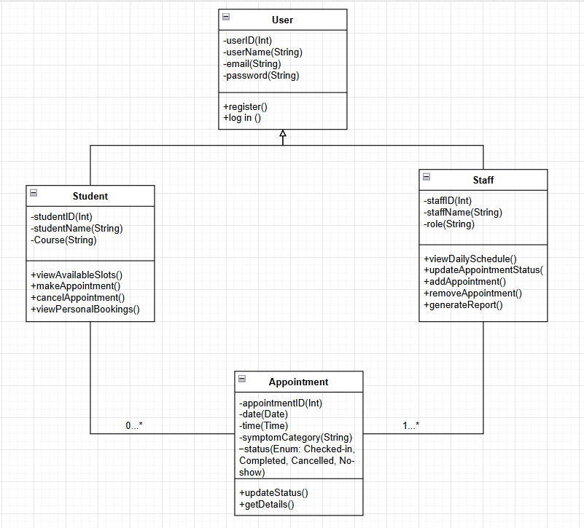
The following diagram shows the essential entities of the UniCare Clinic Booking System, where User is the base class providing shared attributes and methods to Student and Staff. Student has specific fields, such as studentID, studentName, and Course to facilitate functions to check slots and manage appointments. Staff features staffID, staffName, and role to perform duties such as listing daily schedules and modifying appointment statuses. The Student and Staff entities both communicate with the Appointment class, which holds information such as date, time, symptom category, and status (Checked-in, Completed, Cancelled, No-show) and contains functions to modify and read that information. This is a one-to-many relation since Student and Staff may have multiple appointments.

11.2 Use Case Diagram
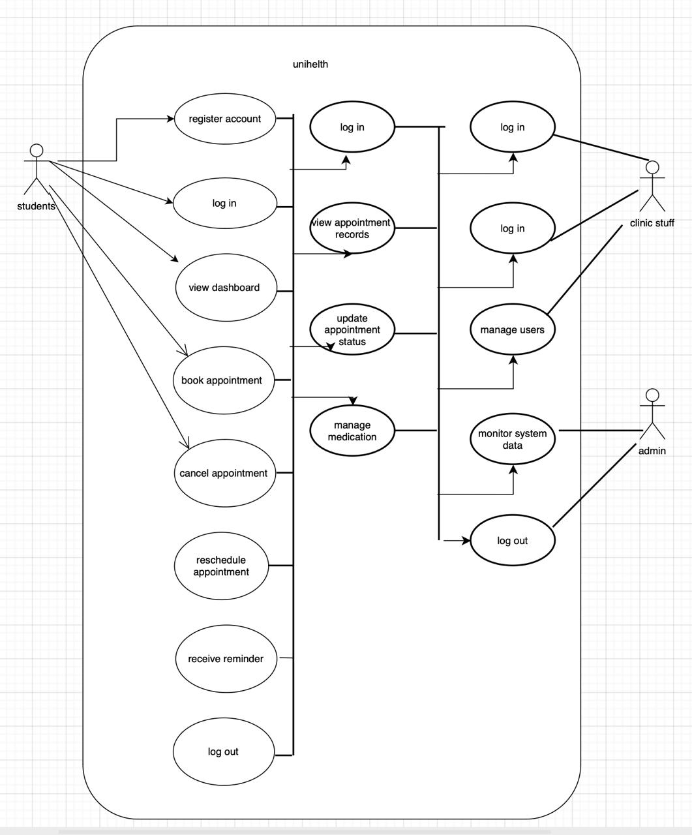

The Use Case Diagram shows how actors interact with the system. The 3 main types of users are Students and Clinic Staff, and Admin . Students may also manage appointments, medications, and reminders through the system. The clinic staff could edit appointment records. User administration and system data monitoring are managed by an Adomin. This diagram is used to describe the system functions.

11.3 Wire Frame
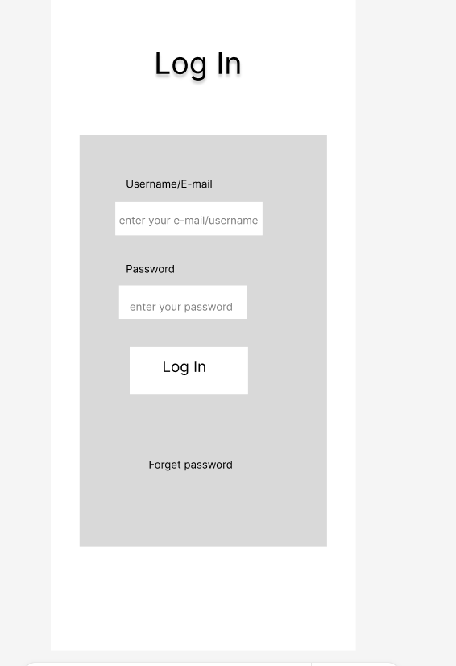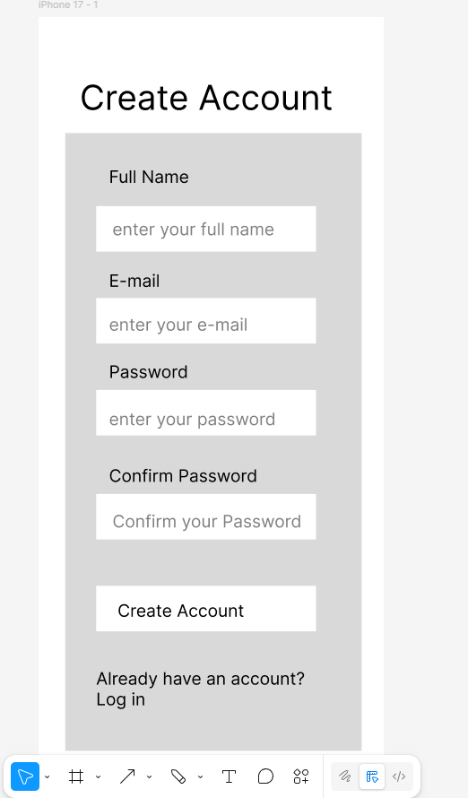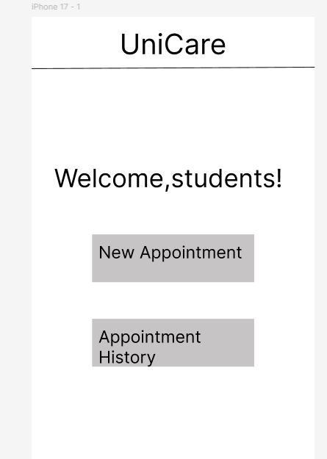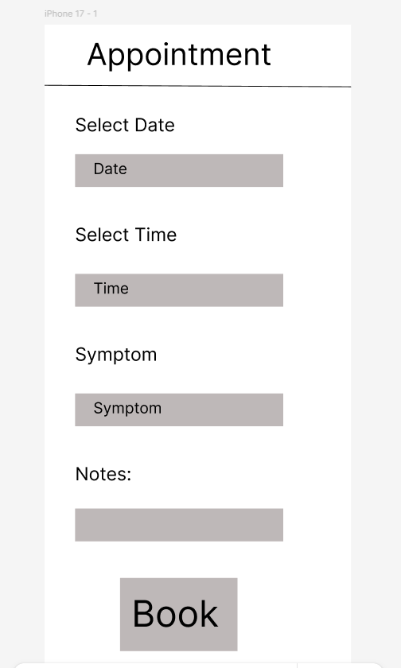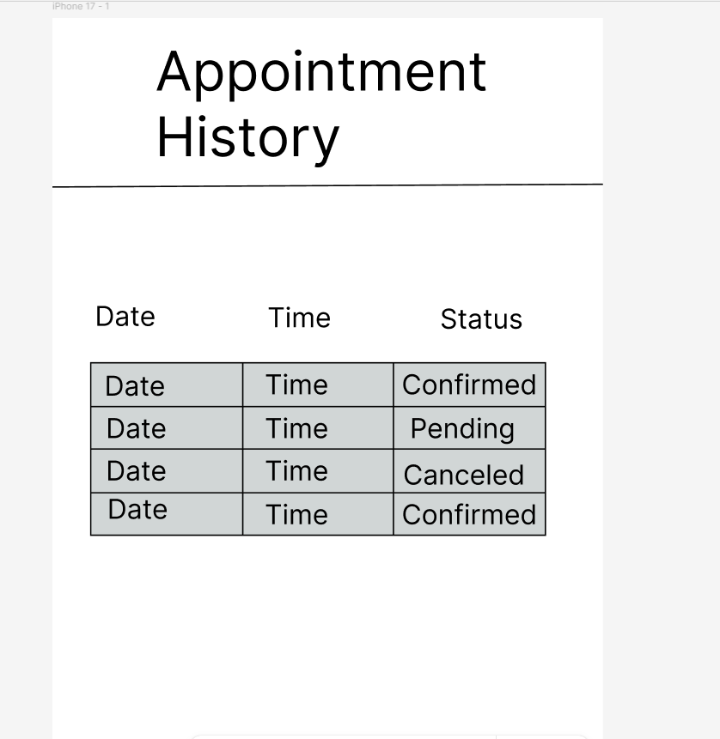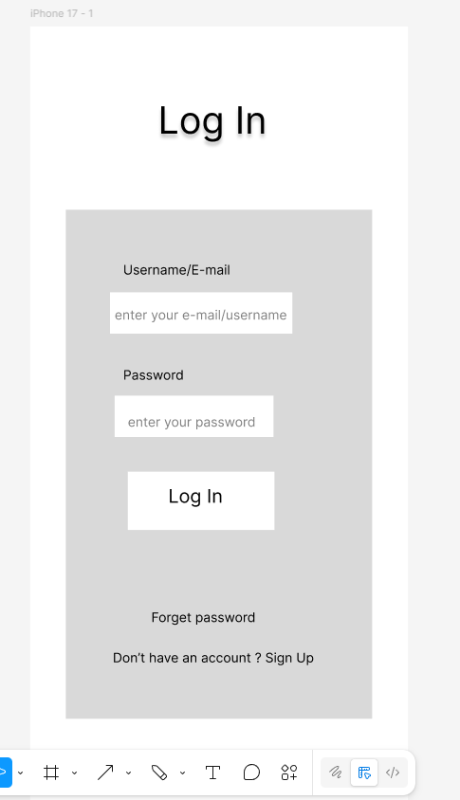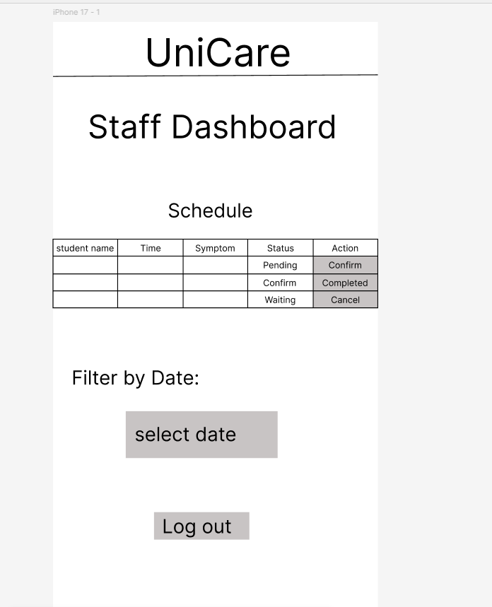

Wireframes were developed to show the layout and user interface of UniCare. The wireframes depict the general layout of important screens such as login, student dashboard, appointment booking, and staff dashboard. These are scaled to be functional rather than pretty or navigable.

12. Prototype Design
A clickable mock-up was built to imitate the basic features of the UniCare system. The prototype enables you to move back and forth between various screens, such as the log in, book appointment, and staff pages. This animated model can be used to show how users will engage with the ultimate system.
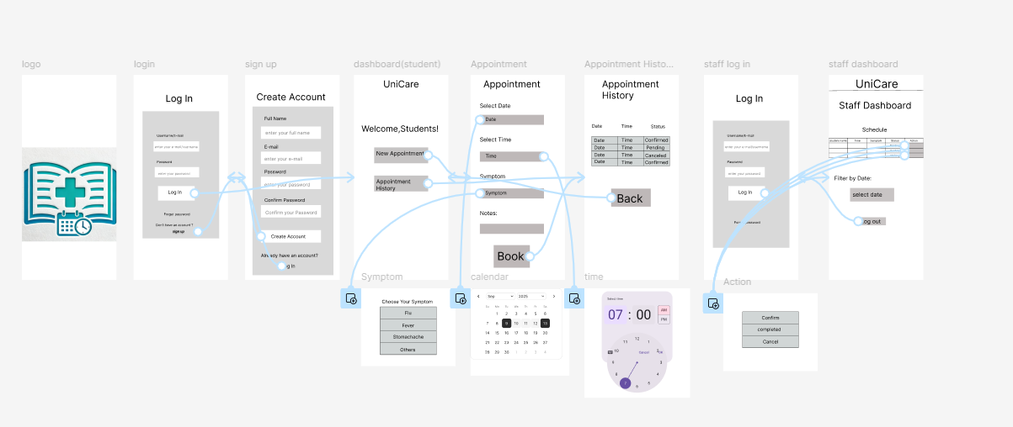
https://www.figma.com/design/dDlrAxgXLE5IqCZSNOQMue/PSE-WireFrame?node-id=11-208&t=aHCleOgYNsKlkwf0-1

13. Testing
13.1 Testing Overview
The UniCare prototype has been tested to confirm that the system works properly and the process is enjoyable for the users. The test was concentrated on the basic features of system, such as user login, account registration, booking an appointment, and viewing the appointment history. A further usability testing was performed to determine whether the users can easily use the interface and do the work.

13.2 Functional Testing

Test Case | Function | Expected Result | Result
TC01 | User Login | The user is able to log in with the correct username and password. | Pass
TC02 | User Registration | User is able to create a new account. | Pass
TC03 | Book Appointment | User Can Select Date and Time and Confirm Booking. | Pass
TC04 | View Appointment History | User able to view history of appointments. | Pass
TC05 | Staff View Appointments | Staffs are able to see students bookings | Pass

Functional testing was done to confirm that every primary function of the UniCare system performs correctly. The results indicate the full system functionality is achievable with the prototype.

13.3 Usability Testing
Three participants were invited to evaluate the prototype of UniCare. Each user was instructed to carry out a number of tasks including logging in, making an appointment, and viewing appointment history. The participants were university students, which are our primary target users.

Testing Tasks:

Tasks | Description
1 | Log in to the UniCare system
2 | Create a new appointment
3 | Select appointment date and time
4 | View appointment history

Testing Feedback:
In general, the participants reported that the system was easy to use and the interface was clear. Most users had no problems accomplishing the tasks. Some participants recommend enhancing the visual design and providing more explicit confirmation messages after making a booking.

14. Agile Artifacts
This section shows artifacts of the Agile development process for the UniCare project. The team leveraged Agile techniques including a product backlog, sprint planning and task management through Trello.

14.1 Product Backlog
The product backlog consists of all system functionalities and work items that are perceived during the planning period.
The user stories were submitted to the backlog and were prioritized by their importance.
Figure 14.1: Product Backlog in Trello
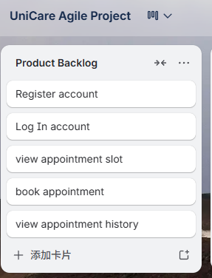

14.2 Sprint Backlog
Sprint backlogs were employed to represent the work scheduled for each sprint. Selected items from the product backlog were taken and assigned to the sprint according to the development priorities.
Figure 14.2: Sprint Tasks in Trello
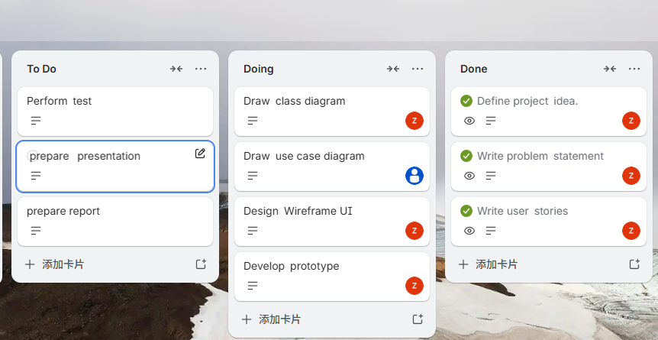

14.3 Kanban Board
Kanban board were used to monitor the stage of task in the project developing process.
The board had four lists:

List | Description
Product Backlog | All planned system features
To Do | Tasks waiting to be started
Doing | Tasks currently in progress
Done | Completed tasks

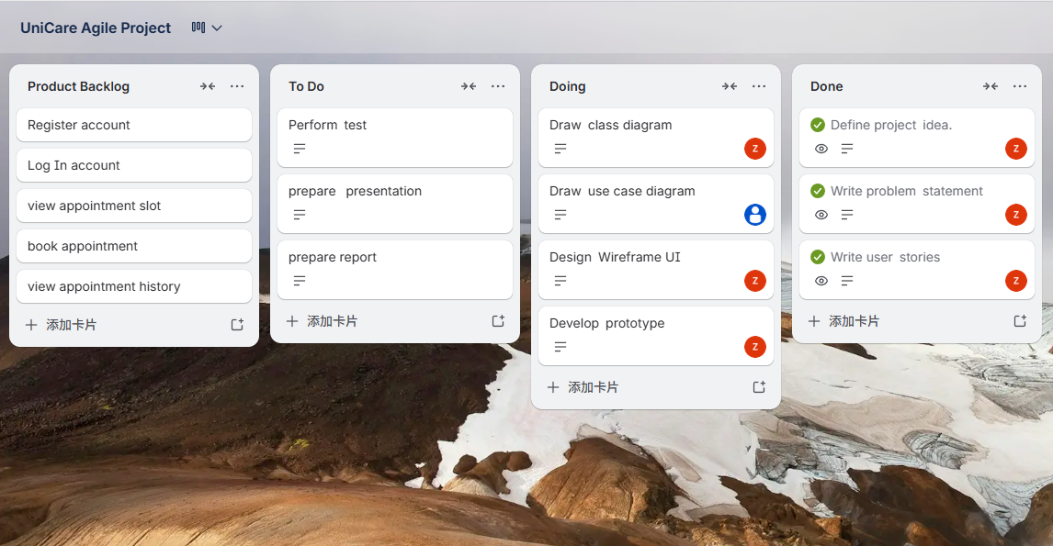

14.4 Burndown Chart
A burndown chart was utilized to track the progress of the sprint and the amount of work remaining in the sprint over time.
The chart depicts the rest of the sprint as a declining number of unfinished tasks.
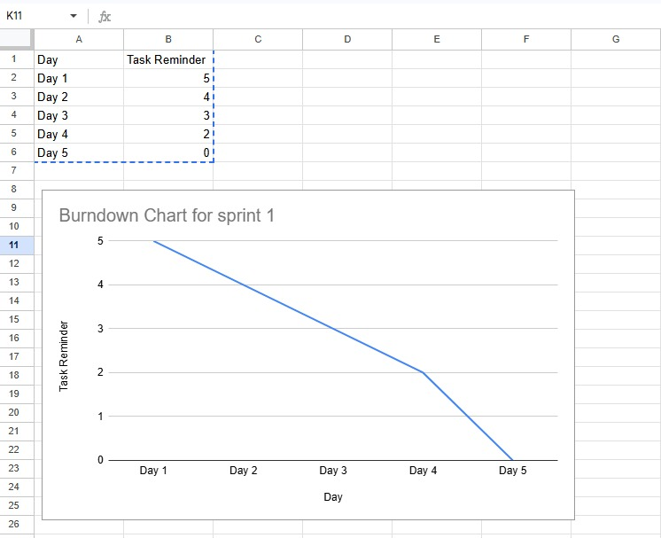
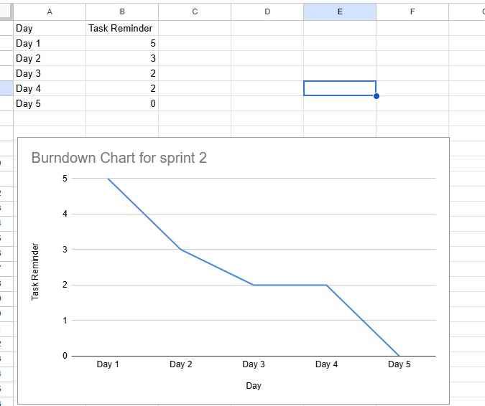

15. GitHub Repository Activity
The project was based on GitHub to handle with the files of the project and to monitor the advancement. The repository was leveraged to hold the project artifacts such as documentation, wireframes, prototypes, testing files, and Agile planning documents.
The team committed frequently with meaningful messages during the Software Development Life Cycle (SDLC) to document the progress.

15.1 Repository Structure
The Github repo was divided into a few folders to maintain a clean project structure.
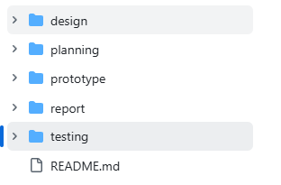
This architecture isolates different sub-systems of a project and also enhances the cooperation of the team developers.

15.2 Commit Activity
There were regular commits during the development of the project. Every commit message has a clean description of the work done.
Example commit messages include:

Commit Message | Description
Add project introduction section | Initial report documentation
Add product backlog and user stories | Agile planning artifact
Upload system wireframes | UI design work
Add prototype screens | Prototype development
Add testing documentation | System testing preparation

Such commit messages allow for tracking progress over time and help to keep the development activity transparent.

15.3 Repository Activity Evidence
The following figure shows the GitHub commit history demonstrating ongoing updates to the project repository.
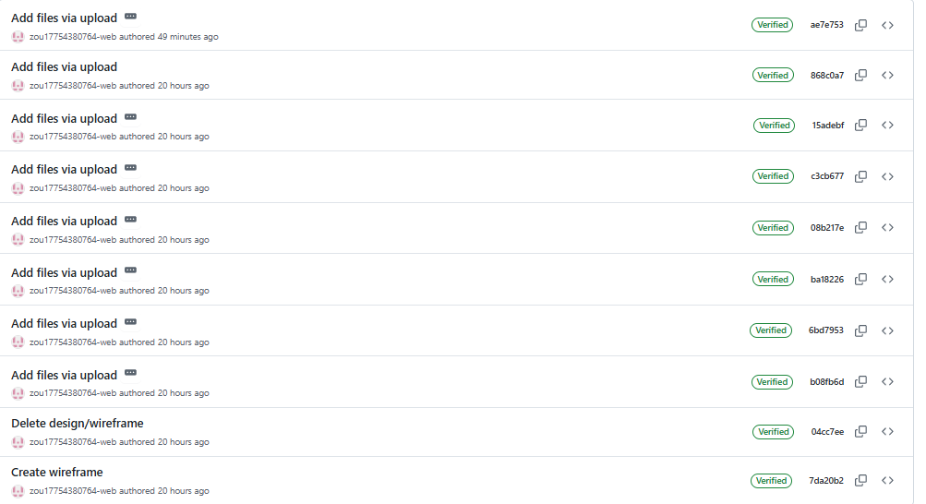

16. Reflections & Lessons Learned
During the UniCare product development, the team learned how to utilize Agile methodologies as a team in an Agile environment. With tools such as Trello to manage tasks and GitHub for version control, they could consolidate the tasks and follow up with the progress on the project.
One of the most important things we learned was how to communicate clearly and divide up the work as a group. As there were team members with different experience levels, this division was made based on the strongest skills among team members according to each stage.
We also learned a great lesson in what Agile development means in practice. Based on sprint planning and iterative development, the team progressively evolved the product and the prototype was gradually enhanced. This whole experience was good in that it actually gave you a shallow dive on teaming, project management, and the software development lifecycle.

17. Conclusion
This work describes the design and development of UniCare, a technology‑based service to increase the utilization of campus health services by making scheduling and managing clinic visits easier. Students may sign up, log in, browse time slots, make appointments, and manage them; clinic employees can keep track of schedules, and alter appointment statuses.
Development was Agile and project/task management was done through Trello, with GitHub used for version control and collaboration. Working sprints finished the team to plan, design and implement a working prototype exhibiting the important capabilities with the system.
In general, UniCare advances SDG 3: Good Health and Well-being by facilitating more accessible healthcare services on the campus. The system can also help in minimizing the waiting time, boost the workflow of the clinic and motivate students to receive medical assistance timely.

Project Report Rubric (20 Marks)

SDLC Phase | Performance Level | Description | Marks Awarded (Lecturer please circle the marks  awarded) | Total Marks / Comments
Requirement s s Planning (SDLC –  Planning s Analysis) | Outstanding (2 marks) | Requirements and planning are clear, well-organised, and aligned with project goals and SDG focus, and there is strong evidence in Trello and GitHub (user stories, backlog items,  and planning files). | 2
 | Average (1 marks) | Requirements and planning are present but somewhat incomplete or unclear, with some supporting evidence in Trello/GitHub but lacking in  detail or organisation. | 1
 | Poor (0 mark) | Requirements and planning are unclear, missing, or poorly aligned with project goals/SDG focus, with little or no  evidence in Trello or GitHub. | 0
Use Case Diagram (SDLC –  Requirement s Analysis) | Outstanding (7 -10 marks) | A Use Case s Class Diagram is submitted that correctly follows UML notation (actors, use cases, system boundary, and relationships) and effectively represents the main functional interactions of the  system. | 7 / 8 / 9 / 10
 | Average (4-6 marks) | Use Case Diagram is present but has one or more notation errors or missing elements (e.g., missing actors, relationships, or unclear boundaries), though basic  interactions are shown. | 4 / 5 / 6

 | Poor (0 -1 mark) | Use Case Diagram is missing or does not follow UML notation, and fails to present  functional interactions clearly. | 0 / 1 / 2 / 3
Design s Prototype Development (SDLC –  Design s Implementati on) | Outstanding (2 marks) | Design artifacts (wireframes, mockups or prototype screens) are clear, logical, and  user-focused, the prototype description clearly explains features and value, and the GitHub design folder is well organised with meaningful commit history showing design  progress over time. | 2
 | Average (1 marks) | Design artifacts and prototype are present and understandable but lack clarity or completeness, and the GitHub design folder contains some organisation and commits but not fully clear or  comprehensive. | 1
 | Poor (0 mark) | Design artifacts or prototype are missing, unclear, or not linked to user value, and the GitHub design folder lacks proper organisation or  meaningful commits. | 0
Agile Process s Tool Usage | Outstanding (3 marks) | Able to clearly explain how Agile practices (e.g., iterative planning, task prioritization, feedback/reflection loops) were applied and explicitly describe how Trello (and other tools, if used) supported these practices, with specific examples of boards, lists, cards, and updates that show  real workflow and adaptation. | 3
 | Average (1-2 marks) | Able to describe some Agile practices and mention use of Trello, but the explanation is general or incomplete, with limited specific examples of how the tool supported  workflow or decisions. | 1 / 2

 | Poor (0–1 mark) | Unable to explain Agile practices meaningfully, or the explanation does not include how Trello was used to support  the Agile process in the project. | 0
Testing / Evaluation (SDLC –  Testing) | Outstanding (2 marks) | Able to clearly explain a structured evaluation with defined test goals and tasks, include user-focused feedback or usability testing results, and show how the findings were used to improve  the prototype. | 2
 | Average (2 marks) | Able to describe some evaluation activity with basic explanation of tasks or feedback, but the process or connection to improvements is limited or only somewhat  systematic. | 2
 | Poor (0–1 mark) | Unable to explain meaningful evaluation or testing activity, lacking clear goals, tasks, feedback, or evidence of improvements based on  evaluation. | 1 / 0
Reflection s Professionali sm (SDLC –  Close s Reflect) | Able to clearly explain how team members collaborated and used tools (Trello, GitHub) to support their work, describe what was learned about SDLC and Agile, and present artefacts and documentation in a clear, organised, and  professional way. |  | 1
 |  |  |  | / 20

